LIGHT FROM STARS

Brightness

• Measured on a scale called apparent magnitude when viewed from Earth.

• It does not measure the actual brightness of a star as the distance from the Earth will change how bright a star appears.

i.e. A very bright star far away will appear very dim from Earth.

• The actual brightness is measured by the absolute magnitude scale - this scale measures the amount of light given off by a star if it is a set distance from Earth.

• For both scales, a negative number means the star is very bright.

• The amount of light given off by a star is determined by its size or amount of matter in it.

e.g. Canopus is 80,000 times more massive than our Sun so it gives off much more light - it has a greater and more negative absolute magnitude.

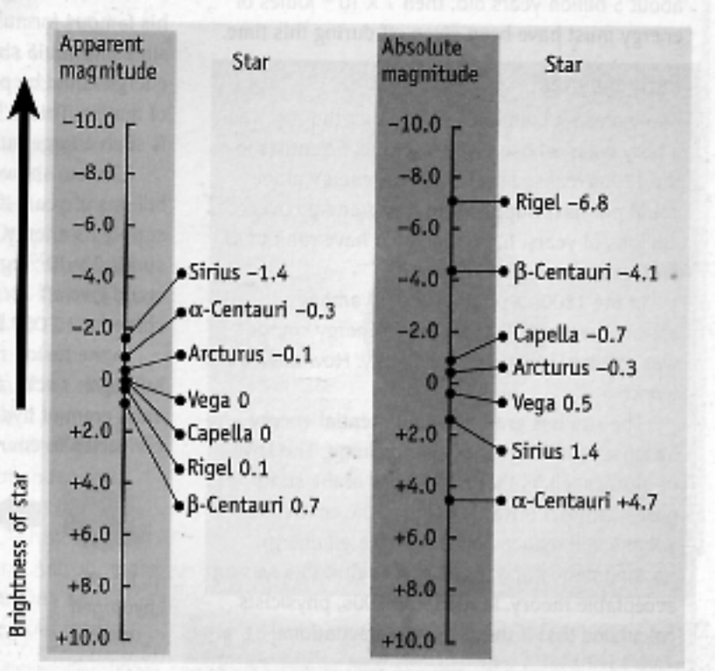

• The absolute magnitude scale is the one used by astronomers to compare stars.

Colour

• Colours of stars vary from red (cool) to blue (hot).

• Astronomers use Wien's Law to calculate the temperature of stars by measuring the
wavelength of light given off.

i.e. Wien's Law: 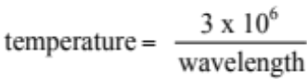

where wavelength is measured in nanometres (x 10⁻⁹ m).

Examples

Two stars with the same colour have the same temperature. If one star has a greater absolute magnitude (brightness), it must be bigger.

A red and blue star can have the same size and absolute magnitude (brightness), but the blue star radiates more energy because it is hotter.

Colour and brightness

An interesting way of displaying the data collected about stars was developed independently by two astronomers, Ejnar Hertzsprung from Denmark and Henry Norris Russell from America. This method has now been named after both of them.
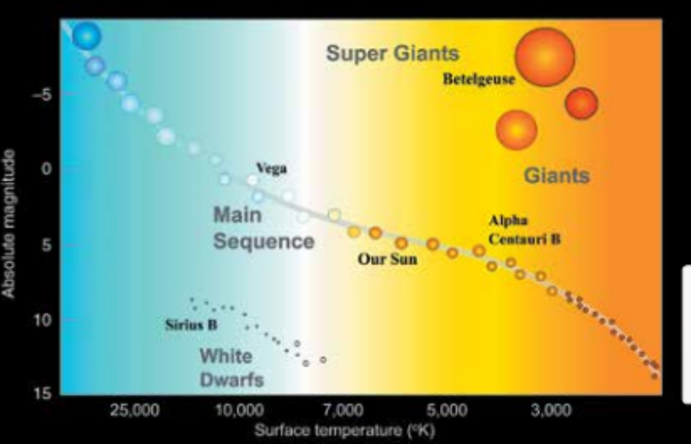
In the Hertzsprung–Russell diagram, the absolute brightness of a star is plotted against its surface temperature, which is deduced from its colour.

When data for many stars are plotted, most of them, including our sun, fall into what is known as the main sequence.

Exactly where a star is found along the main sequence is determined by its mass.

Low-mass stars tend to be cooler and less bright than high-mass stars.

